**Project Report Template**

**TITLE:** Build aEmployee travel Approval Application for corporates

**1. INTRODUCTION**

* 1. **Overview**

Sales force is a customer success platform designed to help the customer sell, service, market analyse and connect with your customer The project aim is to provide real-time knowledge for all the students who have basic knowledge of sales force and looking for a real-time project. This project will also help to those professional who are in cross-technology and wanted to switch to sales force with the help of this project they will gain knowledge and can include into their resume as well.

This Project helps to sending our travel approval requests to the manager in place of emails. This project contain eleven millstones and every milestones having many activities. The milestone-1 tell as how to create Salesforce Org. Milestone-2-11 of this project explained how to creating the Application, What is an object, Tabs, Create- Fields& Relationships, Import Departments, Customize User Interface, Use customization, Adding business Logic to Travel App, reports and dashboards respectively.

* 1. **Purpose:**

A Travel request form helps gather employee trip details and allows you to reject or approve their travel and reimburse their expenses

**2.** **Problem Definition & Design Thinking**

**2.1 Empathy Map**

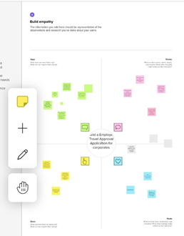

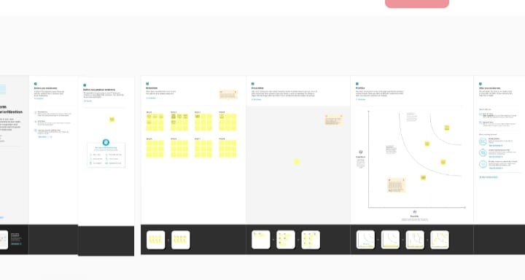**2.2 Ideation & Brainstorming Map**

**3. RESULT**

**3.1 Data Model:**

|  |  |
| --- | --- |
| **Object Name** | **Field in the Object** |
| **Obj - 1**  Standard Objects | |  |  | | --- | --- | | **Field Label** | **Data Type** | | Field Label, | Amount | | Length | 16 | |
| **Obj - 2**  Custom Objects | |  |  | | --- | --- | | **Field Label** | **Data Type** | | Decimal places | 2 | | Select Required | - | |

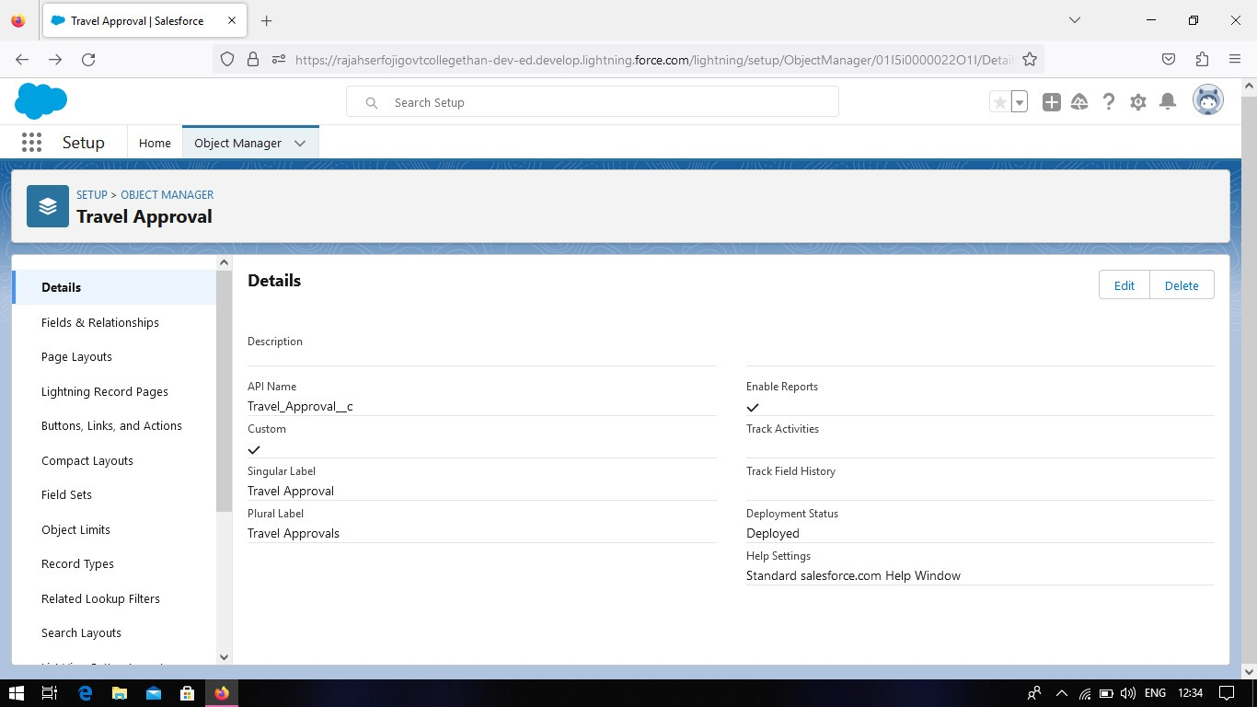**3.2 Activity & Screenshot**

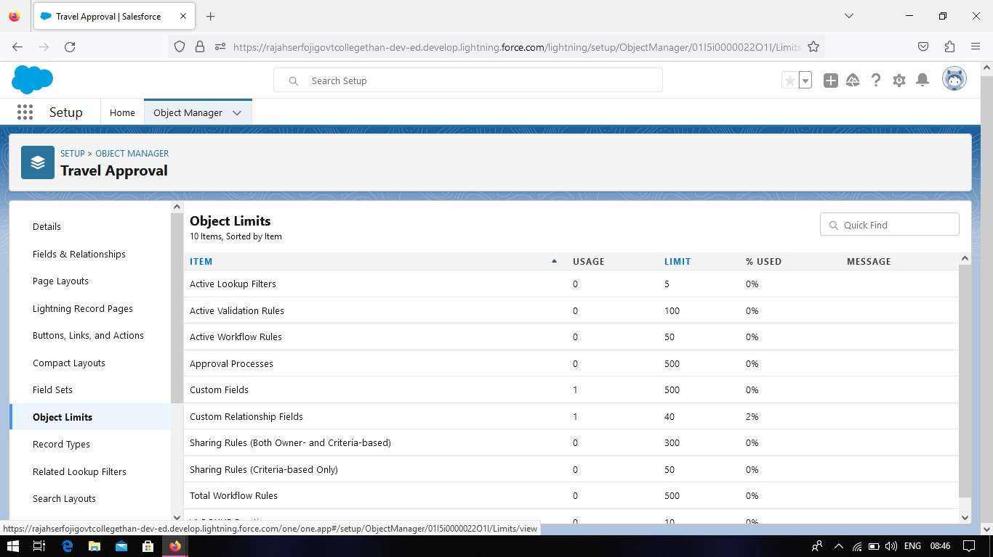



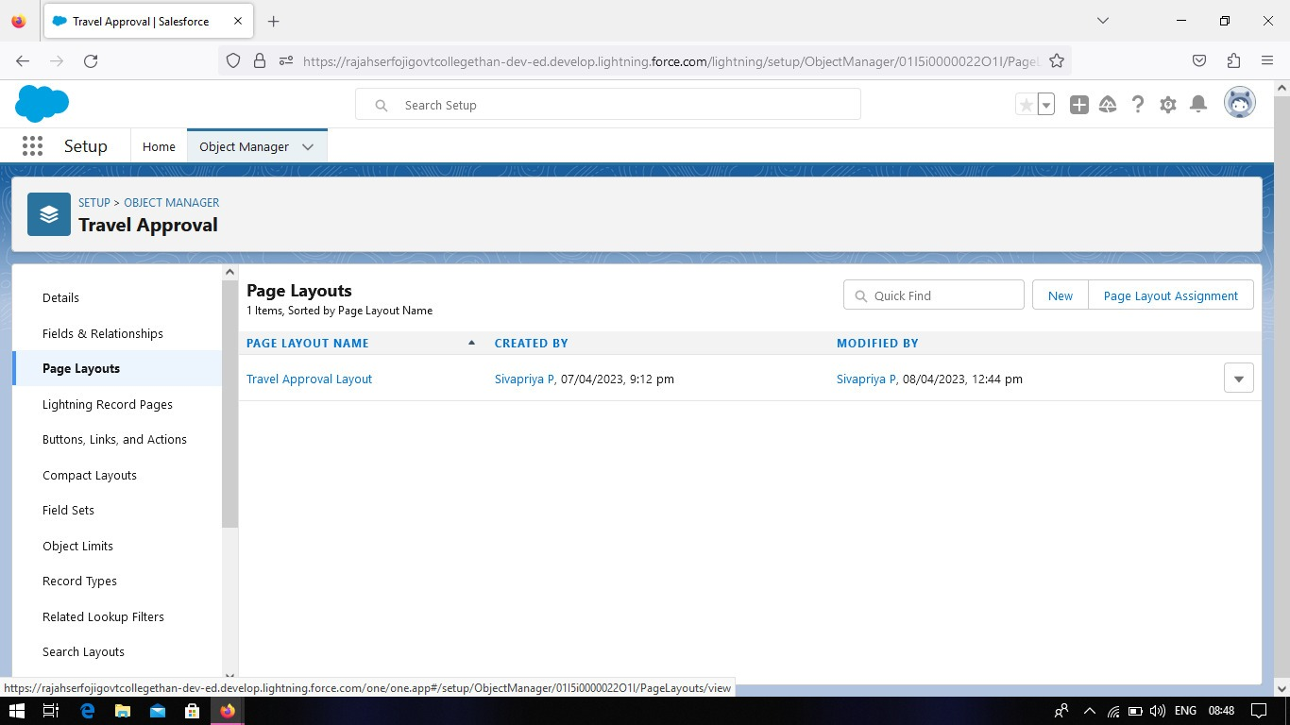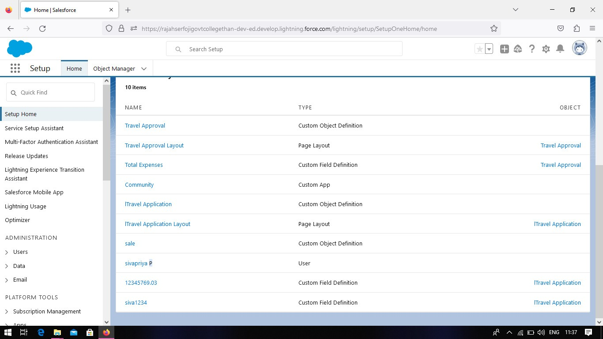

4. Trailhead Profile Public URL

Team Lead - P.Sivapriya -[https://trailblazer.me/id/sivap141](https://trailblazer.me/id/sivap141/hgahlot3)

Team Member 1 –P.Priyadharshini- <https://trailblazer.me/id/priyap23>

Team Member 2 –P.Muthukumar - <https://trailblazer.me/id/muthp11>

Team Member3 –P.Sundhar- <https://trailblazer.me/id/sundharr3871>

**5. ADVANTAGES & DISADVANTAGE**

Advantages:

* Increase Compliance
* Reduce cost
* Faster process

Disadvantages:

It harms health and fitness.

6. APPLICATIONS:

It is used to reduce time.

7. CONCLUSION:

Finally, the project concluded that it is one of the most useful for business travelling

employees.

8. FUTURE SCOPES:

The travel Approval Application growth will be developed large in new technology

systems and easy to travelling and satisfaction of employees.